**CHEESECAKE FACTORY - HEADER IMAGE**

**OVERVIEW/INTRO**

The Cheesecake Factory has nearly 200 restaurants around the world that celebrate the delicious American cuisine and various selections of cheesecake.

Socialtyze partnered with The Cheesecake Factory in 2012 to take over the social strategy and community management, including complete content creation, graphic design, photo & video shoots, crisis management, moderation, social listening, database acquisition, customer analysis, monthly data analysis, paid social media, Twitter chats, sweepstakes & promotions, prize fulfillment and social app development.

**COMMUNITY**

Our content strategy for The Cheesecake Factory’s social channels (Facebook, Instagram and Twitter) is centered on showcasing the many delicious menu options and using fun creative to show off the one of kind dessert selections. Since we first took over The Cheesecake Factory’s social platforms, we have seen tremendous growth across each of their social channels. **(If there’s anything you can add that’s more specific to the voice we use or our strategy for community management, please include).**

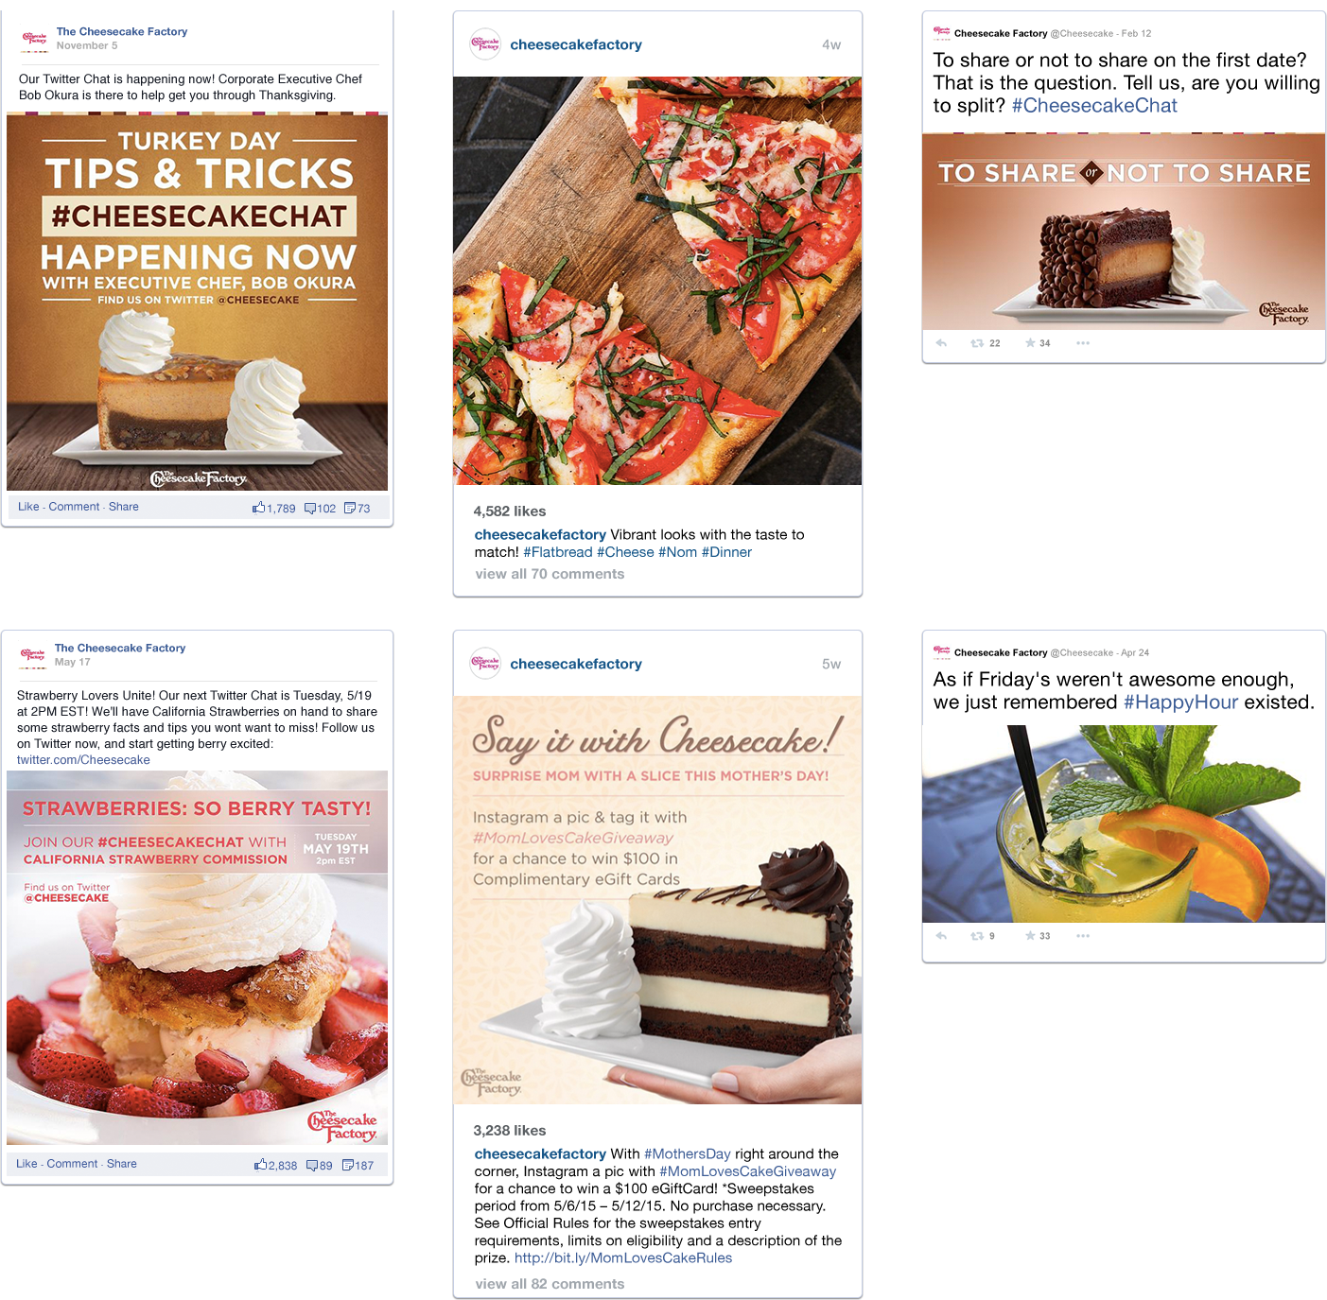

**FACEBOOK PAID MEDIA**

Our social ads for the Cheesecake Factory do three things: generate awareness to put our content on a stage so everyone can see it; drive traffic by identifying and targeting hyper-local audiences located near a Cheesecake Factory; and lead generation, by collecting emails so that they can continue to build a relationship with their Fans outside of social.

We use top-notch data tools to find the right target in Crimson Hexagon and Audience Insights, and work hand-in-hand with our Community Managers to make sure that everything is in line with the larger strategy.

**APPS**

**Cheesecake Madness**

We partnered with the Cheesecake Factory to create an ultimate bracket challenge to find out which cheesecake flavor was most popular amongst our fans. The app featured 32 favorite cheesecake flavors where users voted on their favorite for a chance to win a $250 gift card.

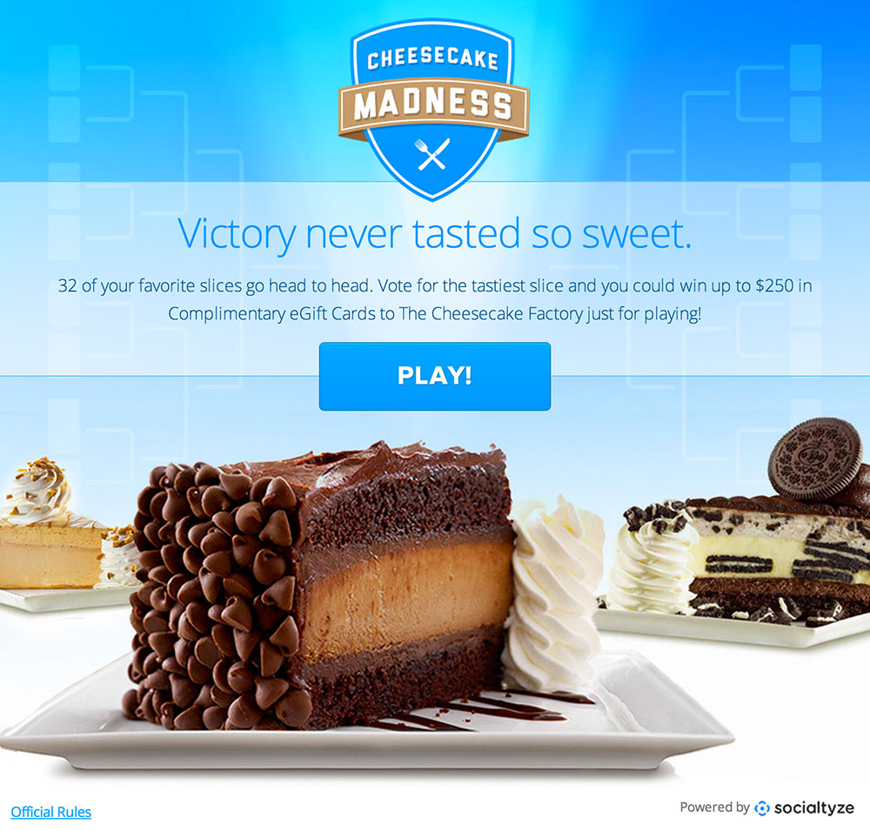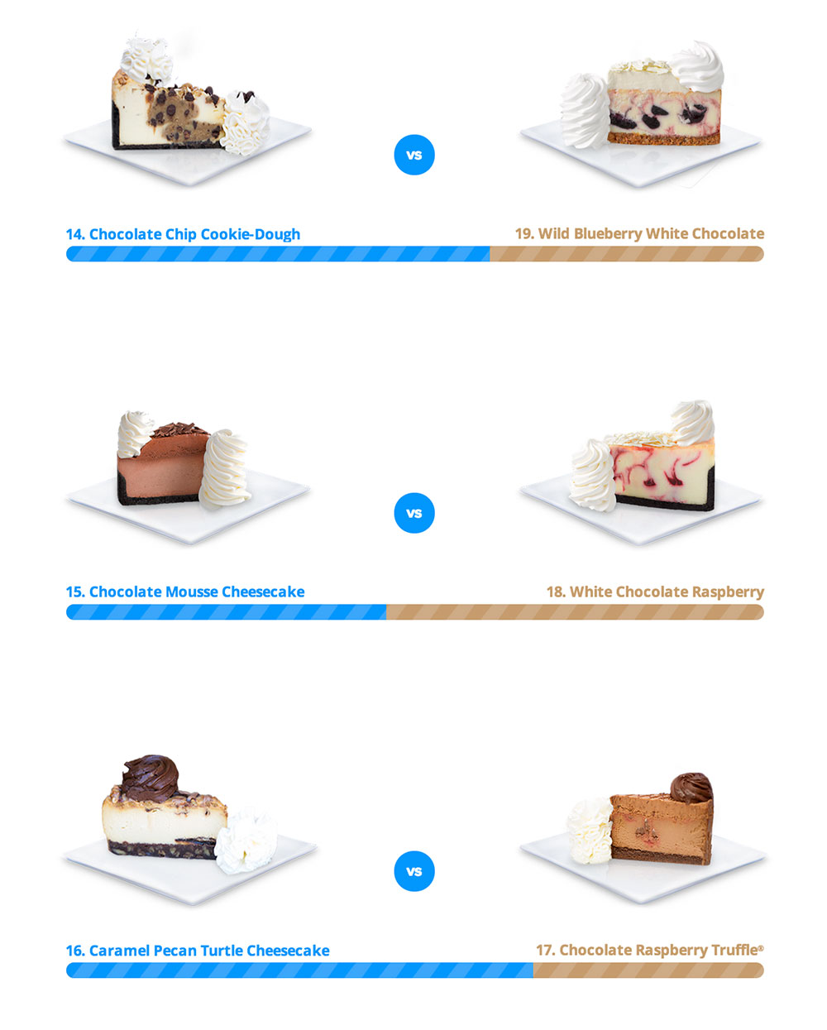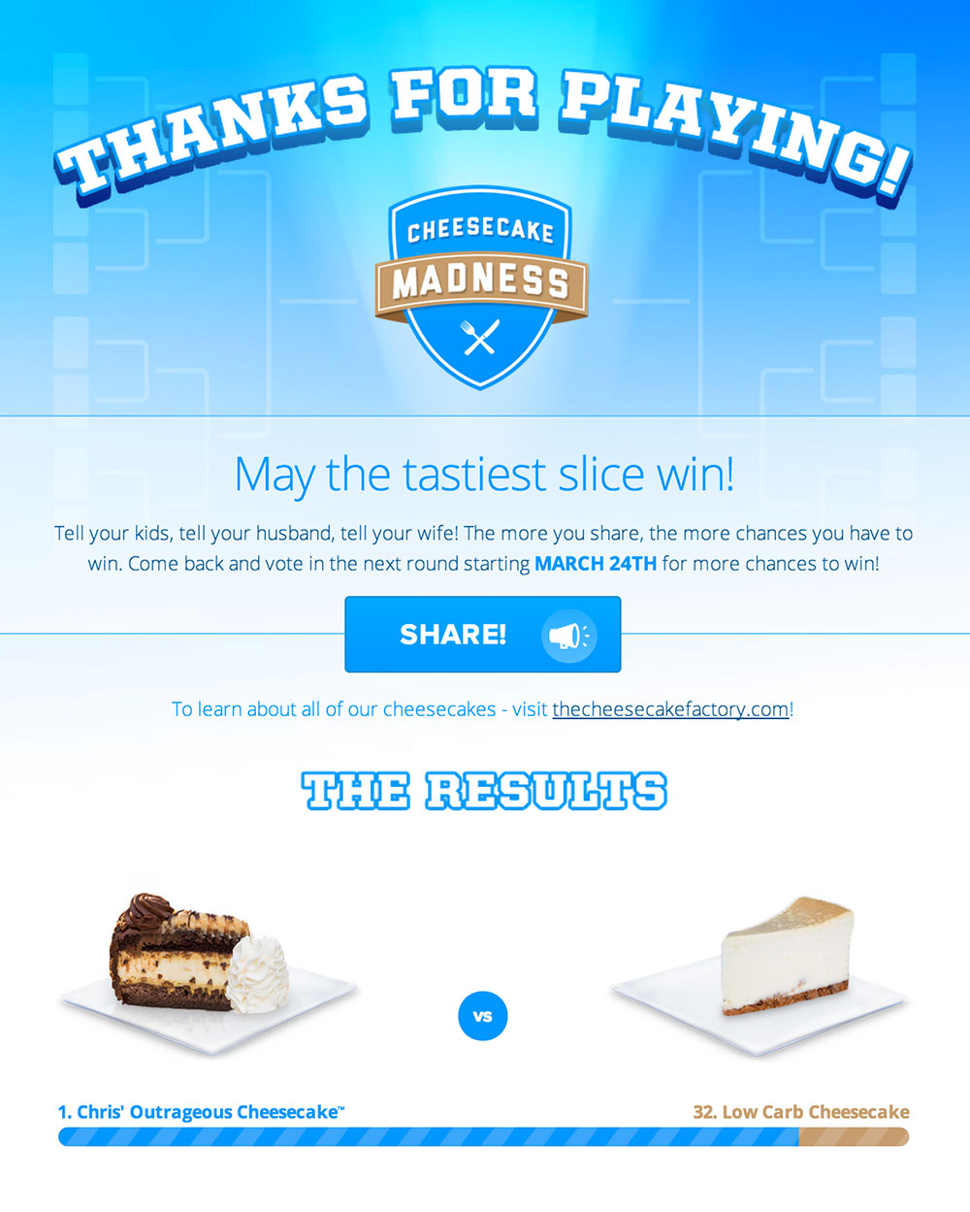

**Say Cheesecake Contest**

To celebrate the annual National Cheesecake Day, Socialtyze created a feed app for Cheesecake Factory fans to post selfies with their favorite slice. Fans who submitted photos were entered to win a $1,000 grand prize and various $100 complimentary gift cards.

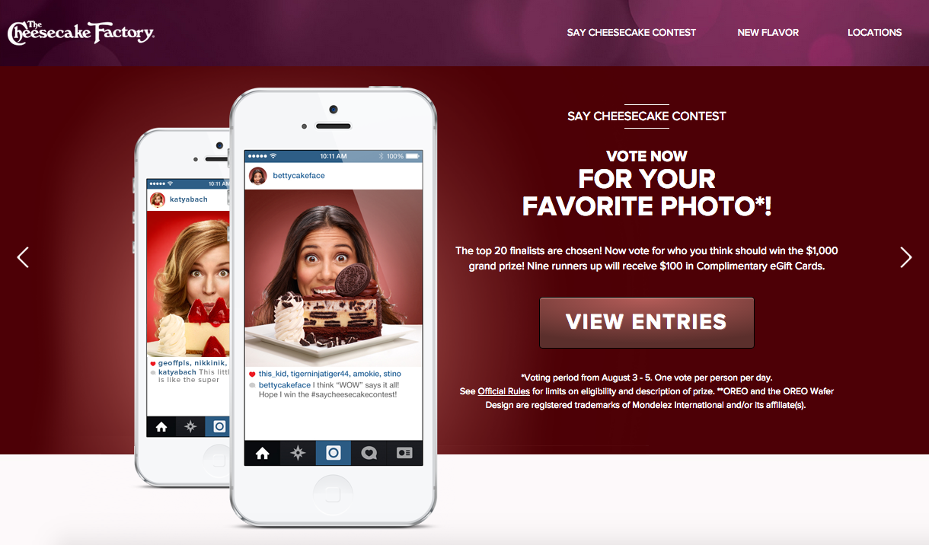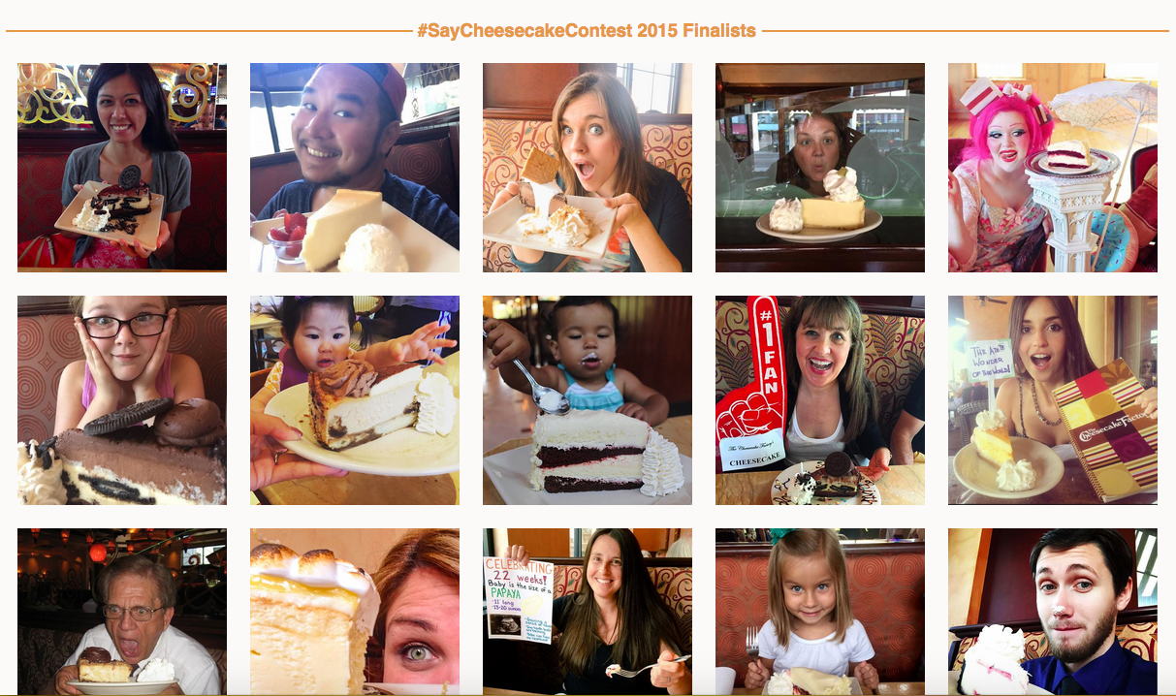

**Father’s Day Movie Sweepstakes**

Socialtyze created a March Madness-style application that pitted 16 films against each other for the crown of “Best Father’s Day Movie Ever”. With each vote, players increased their chances to win movies. Through promotion of highly targeted Facebook ads, e-mail drops, and social posts, the application became an instant hit for fans.

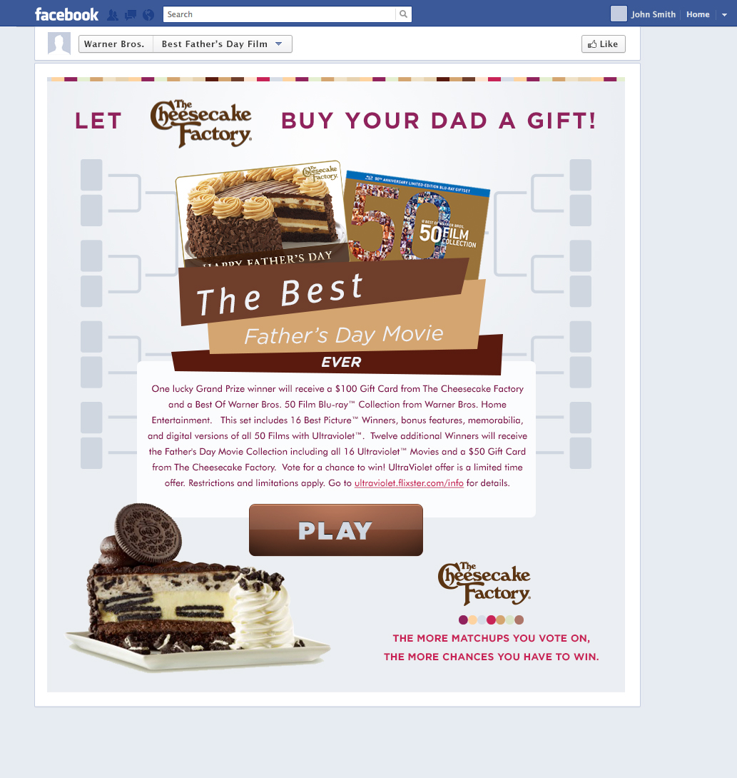 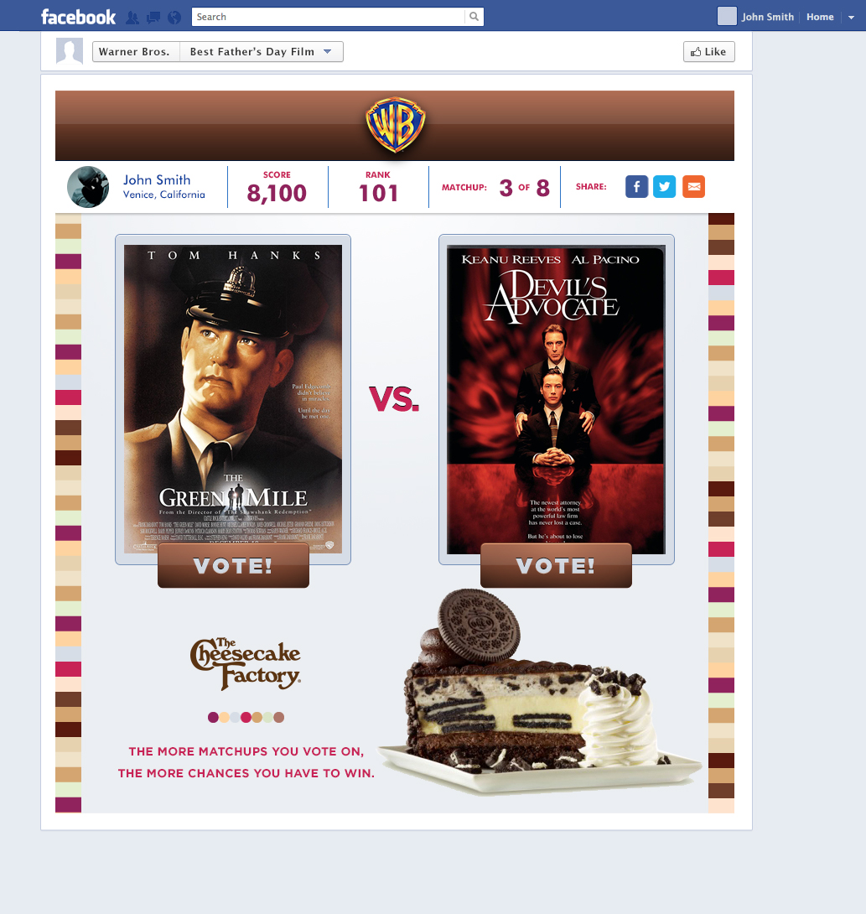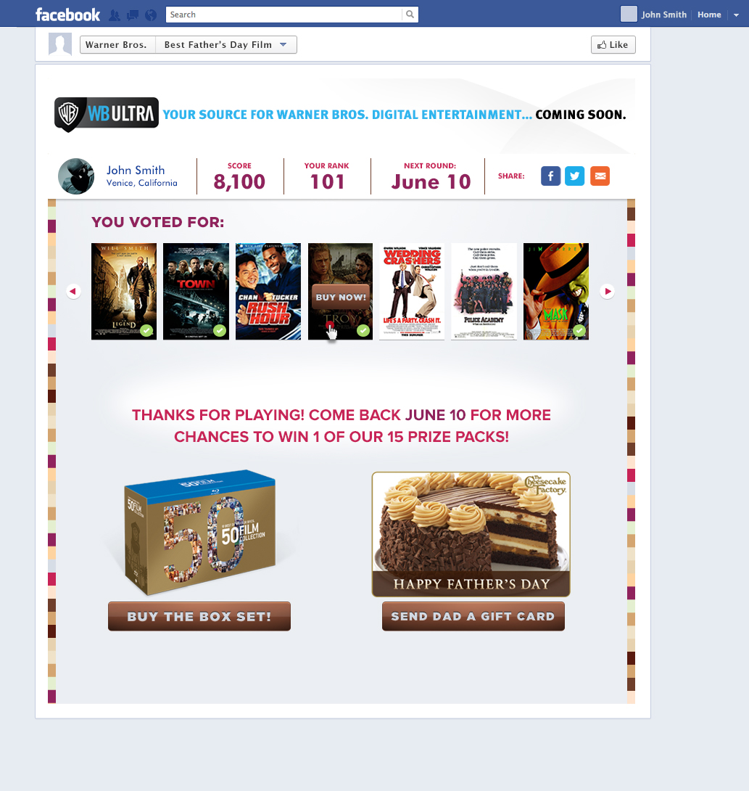

**Trick or Trivia**

To kick off Halloween season, we partnered with The Cheesecake Factory to create an app around the spooky holiday. Trick or Trivia was a movie-quiz app that ran on the various Warner Brother Facebook pages, with prizes including gift cards and movie box sets.

The quiz asked users to match photos with popular movies such as “Where the Wild Things Are” and Pans Labyrinth. To incorporate The Cheesecake Factory’s seasonal Pumpkin Cheesecake, the quiz also included various pumpkin-themed trivia questions such as “What is the largest pumpkin ever grown?” After completion of the quiz, users were shown a leaderboard with their rank amongst other quiz takers.

